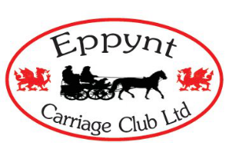
Eppynt Carriage Club Ltd
One Day Entry 2024
Name
Address
Tel No
Email:
Name of Groom
Parent/Guardian Signature for Junior Drivers

Llethercynon Event Date
Name of Affiliated Club you are a member of

PLEASR TICK CLASS ENTERING (TESTS CAN BE FOUND ON BC WEBSITE)
Certius Dressage test |  | Novice Horse
Newcomer |  | Open Horse
Small Pony |  | Pony Multiples
Novice Pony |  | Horse Multiples
Open Pony |  | Long Reining

Entry Fee | Member Over 18 £23.00 | Non Member Over 18  £33.00 | Junior Member Under 18  £23.00 | Junior Non Member Under 18  £33.00

Disclaimer of liability: Neither the LANDOWNER or ORGANISERS of the event or any AGENT, Employee or Representative of the LANDOWNER or ORGANISERS accept any responsibility or liability for any accident, loss, injury or illness to animal, vehicles, drivers, grooms, spectators, land or any other person or property whatsoever, however caused
I have been safety assessed and hold a current certificate of proof
I am carrying a fire extinguisher
I agree to abide by the club rules and accept the above disclaimer and have ticked all the boxes

Signed |  | Date

Please send entry form and fee to: Brenda Cowdell, 2 Bungalow, Llaneglwys, Builth Wells, Powys LD2 3BQ Cheques payable to Eppynt Carriage Club Ltd
Online entries to: e.c.c.membership.secretary@hotmail.com Bank transfers to: 30 63 59 20564960

Please use this space for any additional information that you think will help the organisers: eg: sharing grooms or carriages or if you want a later or earlier start time.

